A well-documented case of seismic activity potentially induced by wastewater injection was an intense sequence of earthquake swarms that occurred near the towns of Guy and Greenbrier, Arkansas (Fig. 1), between August 2010 and June 2011 (Horton, 2012). The earthquakes started within a few weeks after beginning of injection at nearby wells (less than 6 km away), and after a period of intense activity, gradually stopped within a three-month period following injection termination.

Several earthquake catalogs exist for this sequence based on different detection methods: Horton (2012) (ANSS) and Ogwari et al. (2016) based on STA/LTA, Huang and Beroza, (2015) based on templet matching, Yoon et al., (2017) based on FAST, and Mousavi et al (2018) based on deep learning. August 2010 is the overlapping time period in these catalogs, hence we made a unified catalog for this period combining information of all the above catalogs containing 3788 events. Most of these events are microearthquakes with local magnitudes ranging from -1.3 to 0.5 associated with hydraulic fracturing or wastewater injection. Events are located within a 2 km area at 2 to 4 km depths (Figure 2).

Continuous data:

Continuous seismic data are provided for I month (August 2010) for 3 components (HHE, HHN, HHZ) of station WHAR. Data are in SAC format for each component.

The catalog is available at:

<https://github.com/smousavi05/Arkansas_catalog>



**Figure 1.** Epicentral and cross-sectional distributions of seismicity in the study area (between 7 July and 20 October 2010). Marker sizes are scaled to event sizes. Seismic stations are shown by white triangles and black diamonds are disposal wells. The Enders fault is shown by a solid black line. (Figure from Mousavi et al 2017)

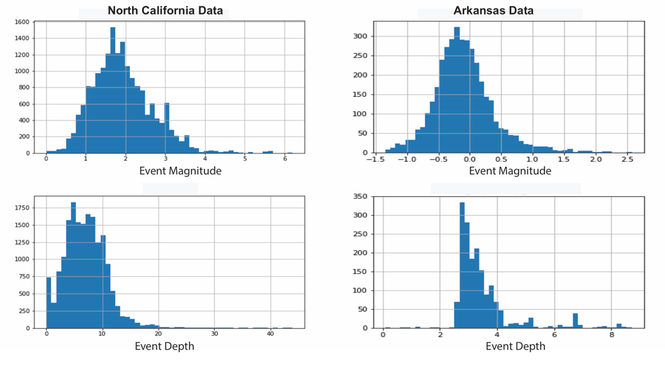

**Figure 2.** Distribution of event magnitudes and depths in the unified catalog.

**References**

Horton, S. (2012). Disposal of hydrofracking waste fluid by injection into subsurface aquifers triggers earthquake swarm in central Arkansas with potential for damaging earthquake. Seismological Research Letters. 83, 250–260.

Mousavi, S. M., Horton, S. Ogwari, P., & Langston, C. A. (2017). Spatio-temporal Evolution of Frequency-Magnitude Distribution during Initiation of Induced Seismicity at Guy-Greenbrier, Arkansas. Physics of the Earth and Planetary Interiors. 267, 53-66, [http://doi.org/10.1016/j.pepi.2017.04.005](http://www.sciencedirect.com/science/article/pii/S0031920117300444)

Mousavi, S. M., W., Zhu, Y. Sheng, and G. C. Beroza, (2018). CRED: A deep residual network of convolutional and recurrent units for earthquake signal detection, Nature-Scientific Report, [arXiv:1810.01965](https://arxiv.org/abs/1810.01965).

Ogwari, P.O., Horton, S.P., & Ausbrooks, S., (2016). Characteristics of induced/triggered earthquakes during the startup phase of the guy-greenbrier earthquake sequence in North-Central Arkansas. Seismological Research Letters. 87 (3), 620–630. <http://dx.doi.org/10.1785/0220150252>

Huang, Y., & Beroza, G.C. (2015). Temporal variation in the magnitude-frequency distribution during the guy-greenbrier earthquake sequence. Geophysical Research Letters. 42 (16), 6639–6646. <http://dx.doi.org/10.1002/2015GL065170>.

Yoon, C. E., Huang, Y., Ellsworth, W. L. & Beroza, G. C. (2017) Seismicity During the Initial Stages of the Guy-Greenbrier, Arkansas, Earthquake Sequence, Journal of Geophysical Research – Solid Earth, 122, 9253-9274